Ideation Phase
Brainstorm & Idea Prioritization Template

Date | 31 January 2026
Team ID | LTVIP2026TMIDS87433
Project Name | Rain Prediction Pipeline Flask
Maximum Marks | 4 Marks

Brainstorm & Idea Prioritization:
Our team discussed common problems related to weather prediction, especially the difficulty in knowing whether it will rain in advance. Each member shared ideas such as weather apps, alert systems, and prediction websites.
After discussion, we selected Rainfall Prediction using Machine Learning as our project. This idea was chosen because it solves a real-world problem and allows us to apply data analysis, machine learning models, and web deployment using Flask.
We finalized this idea based on:
- Easy availability of weather data
- Practical use for farmers and planners
- Scope to implement ML concepts
- Ability to deploy as a web application
Final Selected Idea: Rainfall Prediction System using Machine Learning and Flask.

Step-1: Team Gathering, Collaboration and Select the Problem Statement
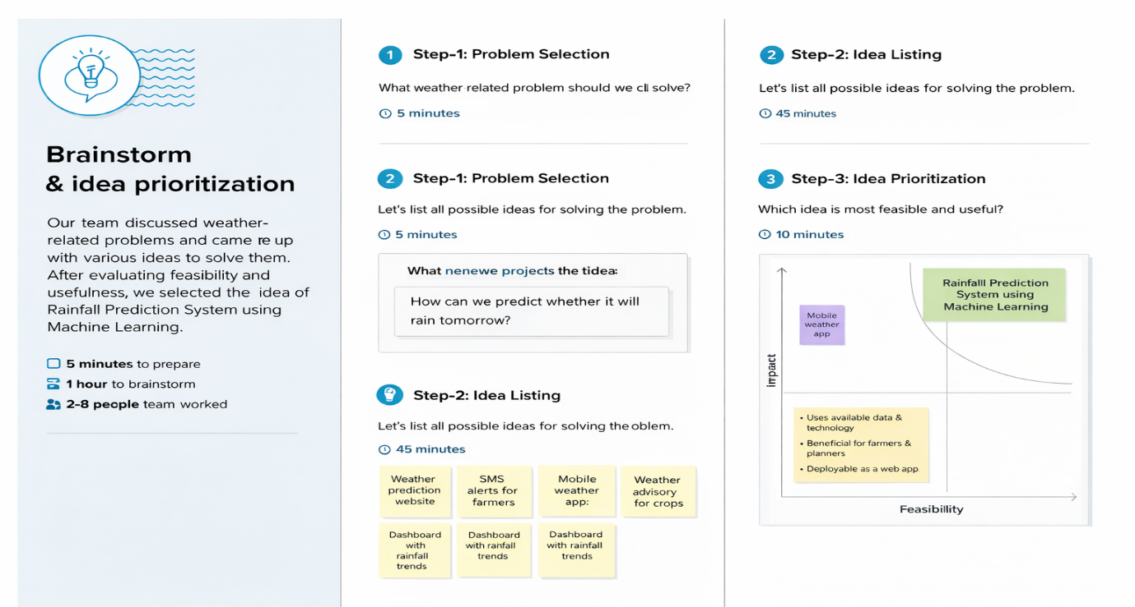

Step-2: Brainstorm, Idea Listing and Grouping
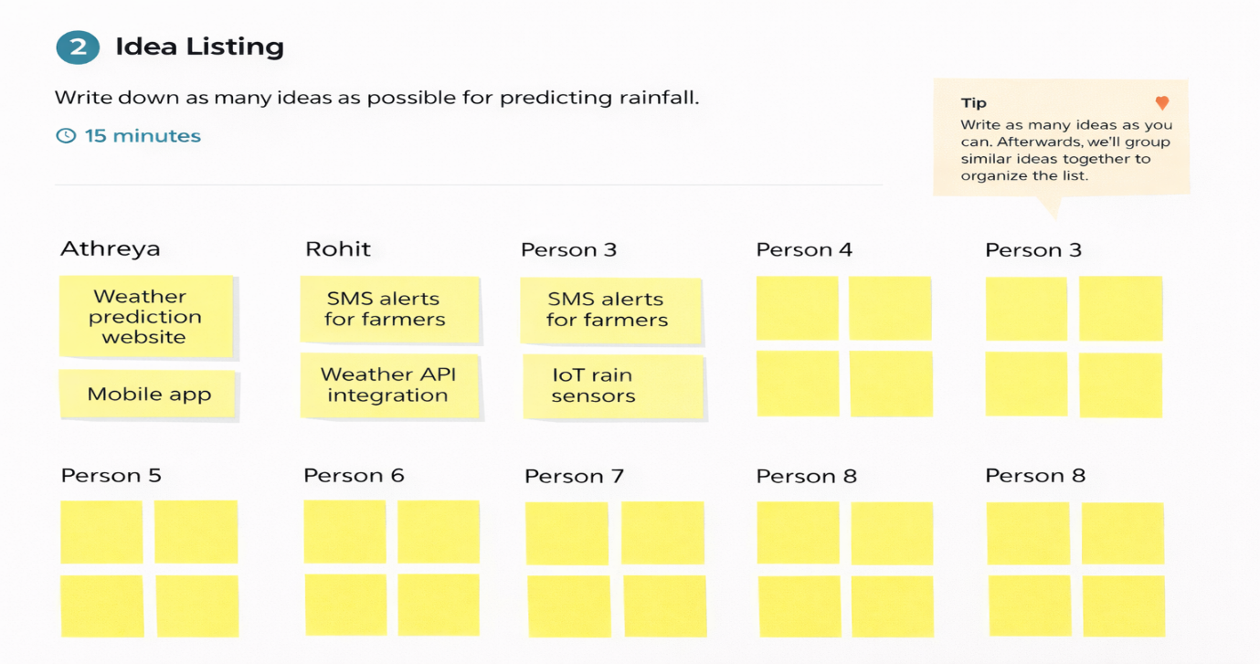

Step-3: Idea Prioritization
